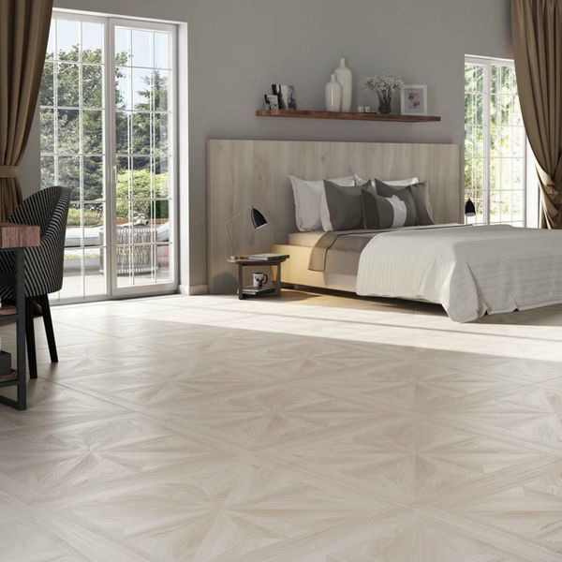**Antoinette Parquet Whiteleaf Jewel Wood Tiles:**

## **Product Description**

Create a luxurious look in your interior spaces with these gorgeous Antoinette Parquet Whiteleaf Jewel Wood Tiles. Made from porcelain, they're durable and long-lasting. They have a naturalistic matt finish with a decorative parquet effect pattern; giving the illusion of an expensive, lovingly carpentered wooden floor.

**What's special about these tiles?**

> Decorative parquet effect pattern  
> Realistic wood effect design  
> Ideal for creating a luxury vintage look  
> Naturalistic matt finish  
> Made from durable, long-lasting porcelain  
> Suitable for use with underfloor heating

**Try before you buy**

If you'd like to take a closer look, why not order a sample tile? Samples are a great way to get a feel for a tile's true colour and texture, and you can see how it looks in your chosen room!

## **Product Info**

* Product ID: 38478
* Tiles Per SQM: 1.5625
* Sale by: Per SQM
* Size: 800x800mm
* Weight: 14.08 KG
* Material Type: Porcelain
* Finish: Matt
* Colour: White
* Suitability: Floors
* Grade: 4
* Rectified Edge: Yes
* Underfloor Heating: Yes
* Anti Slip Grade: R10 / 10-19 Degrees
* Thickness (mm): 10